



amitbhatia33@gmail.com | +91-99103-76231 | Ghaziabad, Delhi NCR, India | linkedin.com/in/amitbhatia33 | amitbhatia33
Amit Bhatia
HR Professional
I am an HR Professional with a blend of Business & HR together having clear focus on Value creation,
Solutions & Results.

Purpose: Help Employees & Organization to Perform Better & Grow by Creating Value.
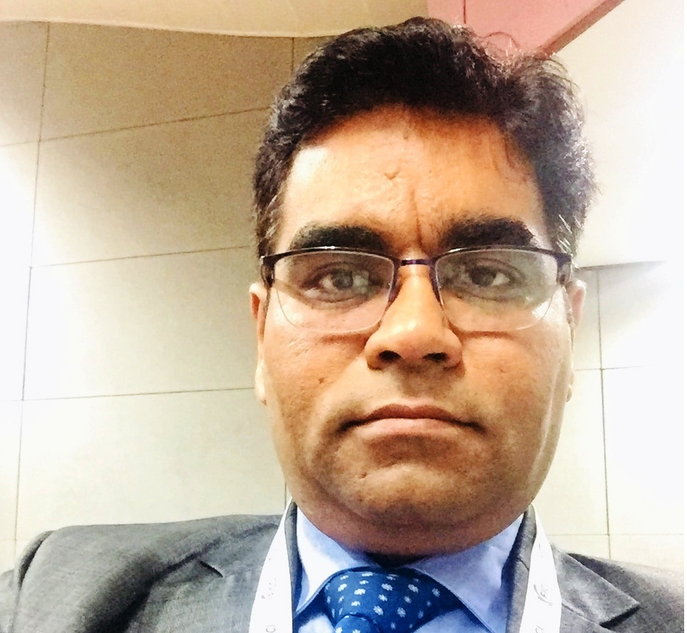

Human Resource Skills & Exposures
- Human Resource Planning  - Talent Acquisition  - Lateral Hiring  - Fresher Hiring  - Expansions  - Interviews & Psychometric Assessments  - Campus Connect  - On-boarding, Induction & Orientation | - Performance Management  - Competency Mapping & Strategic Alignment  - Employee Engagement  - Employee Communication  - OD Interventions  - Succession Planning  - Development Centers | - Assessment Centers  - Retention & Attrition Control  - Coaching & Mentoring  - People Development  - Corporate HR  - Defining HR Processes & Systems  - HRIS  - GAP Analysis | - Com & Ben Admin  - Benchmarking  - Contractual Employee Management  - Legal Compliances & Inspections  - Trade Union Negotiations.  - IR Issues & Court Cases  - Plant HR  - General Administration  - HR Policy Formation & Budgeting

Present Employer (Feb’16-) | Current Role | Current Responsibility | Achievements
Wockhardt Ltd  Manager-HR  HRBP- North Zone/Delhi  Wockhardt is a global pharmaceutical and biotechnology organisation Head Quartered in Mumbai. It is India’s leading research-based global healthcare enterprise with relevance in the fields of Pharmaceuticals, Biotechnology and a chain of advanced Super Specialty Hospitals. | Talent Acquisition  - Induction & Onboarding  - Talent Management  - Performance Management  - Capability Building & OD workshops  - Succession Planning  - Employee Relations  - Trade Union Negotiations  - IR & Court Matters  - Counseling & Conflict Resolution  - Campus Connect  Attrition Control | I am Leading Human Resources function for North India Region covering 8 States and supporting 950+ EMPLOYEES for India Pharma Business (Sales Function) for End to End HR Support. I am working closely with the Head HR with a strong team of 52 People Managers (internal customers) to facilitate the Sales HR Activities for Territory Managers, Area Managers & Zonal Sales Managers for 15 Business Units (Divisions). | Successfully Reduced Field Attrition by 13% (39%-32%-26%) in Wockhardt with an achievement of 24% Regrettable Attrition against a target of 25%.  Successfully saved an approx. cost of INR 13 mn out of reduced attrition.  Settled 4 critical IR cases without litigations.  Settled PF demand of Rs 1.28 Lac for 27k only without & penalty.

Previous Working Experience & ACHIEVEMENTS

Employer | Role | Responsibility | Achievements
Abbott India/Delhi  TA & HRBP- North Zone.  Chief Manager-HR  June -2011-Feb-2016  Abbott is a renowned & leading US Pharma MNC present in various segments of Healthcare & Life Sciences viz. Pharmaceuticals, Nutrition, Diagnostics, Medical Optics, Devices. | - Talent Acquisition  - Lateral Hiring  - Fresher Hiring  - Expansions  - Psychometric Assessments  - Campus Connect  - On-boarding, Induction & Orientation.  - Development Centres  - PMS & Gen. Management  - Succession Planning  - Competency Mapping & Strategic Alignment | I lead Sales TA & BHR function for North India Region covering 8 States for 3 Organizations having 32 Business Units viz. Abbott Healthcare, Abbott India & Abbott True Care. I was supported by 2 direct reports. | - Elevated as Chief Manager-HR  - Awarded with Gold Award in recognition of work performance at Abbott Healthcare in for 2012.  - Awarded with Team Award in recognition for exceptional contribution in Abbott in for 2014.  Saved minimum INR 12 mn under Hiring & Employee cost, by implementing Campus Connect & hiring strategy in 2 years 2014 & 2015 in Abbott.

Employer | Role | Responsibility | Achievements
Pfizer Ltd /Mumbai (Continued Employment from RFCL )- Corporate & Business –HR-PAN India  Assistant Manager-HR  Apr -2007-June-2011  Pfizer Inc. is a renowned & Top US Pharma MNC present in various segments of Healthcare & Life Sciences viz. Pharmaceuticals, Nutrition, Diagnostics etc. | Talent Acquisition  Corporate HR  On-boarding, Induction & Orientation.  Com & Benefits Admin  PMS  Payroll Admin with Finance.  HR Generalist & workplace issues.  Grievance Handling | I was migrated to Pfizer thru Vetnex (RFCL) acquisition, where initially I was responsible for smooth integration of Vetnex into Pfizer with no HR issues. Later I was given the HR responsibility to support, 2 Business Units & Corporate Office along with Plant Employees (total 1200 HC). I was based in Mumbai Office & closely worked with the Senior HR management. | - Successful migration of Vetnex into Pfizer with no litigations or issues.  - Awarded a One Time Special Spot Bonus of US $ 2,500 by HR Leadership Team in Pfizer HR for special contribution for year 2010.  - Streamlined On-Boarding.

Employer | Role | Responsibility | Achievements
RFCL-Ranbaxy/ Delhi  Executive HR (Corp. & Business)  Nov 2005 to March 2007  RFCL Ltd erstwhile known as Ranbaxy Fine Chemicals Ltd, was separated out of Ranbaxy Allied Business, consists of 3 SBU, Rankem (Fine Chemicals), Diagnova (Diagnostics) & Vetnex (Animal Health), and was funded by I Venture (ICICI Venture Pvt Equity). | Contractual Employee Management  - Talent Acquisition  - Induction & Onboarding  - Performance Management  - Defining HR Processes, Systems & Policies  - HR Budgeting  - Legal Compliances & Inspections (PF, ESIC, etc)  Plant HR & Trade Union Negotiations  - IR & Court Matters  - HRIS & GAP Analysis  - Resolving Plant IR Issues. | I joined RFCL when it was coming out of Ranbaxy Pharma & was being formed as new entity. I was part of core HR team & was responsible streamlining the HR processes for all the 3 SBUs for pan India level. I was HR SPOC during construction of Mfg Plant at Haridwar & was solely responsible for management of 200+ Temp Employees including their payroll with vendor & all legal compliances along with corporate HR. | - Saved around INR 2 MN against of legal compliance cost by proactive measures in RFCL.  - A 6 Sigma Project on Recruitment in RFCL Ltd with 6 Sigma achievements.  Awarded with Yellow Belt Certificate  Annual RFCL Award for Exemplary Performance- Consecutively for 2 years Dec-08 & Dec-09.

ACADEMIA
Post Graduation | Post Graduation | Graduation | Other
Post Graduate Diploma in HR with 1st Div. IMT-Ghaziabad (CDL)  2015-16 | MBA- Human Resources Certificate with 1st Div,  Annamalai University (DE)  2006-2008 | Bachelor of Arts (BA) in Economics with 2nd Div,  Delhi University (DE)  1996-99 | Advanced Diploma in Sales & Marketing Management, with 1st Div  National Institute Of Sales (NIS), New Delhi, Full Time 1998

Certifications & Trainings
The Predictive Index (US) Certified (2017)  (Psychometric Assessment) | Train The Trainer (NHRDN) Trained Professional (2016) | 2 days Training Program on Contract Labour Management by Professor M R Gera (AIMA) 2010 | Certificate Course in Interviewing Skills, (Online Education)  The Saylor Foundation, Washington DC, U.S.A ’2013

NATURAL STRENGTHS & PERSONALITY TRAITS
Natural Strengths: - Activator | Empathy | Relator | Arranger | Achiever (Reference: - http://www.strengthsfinder.com)
Easily Approachable, Clear, Analytical, Active, Conceptual, Decisive, Focused, Pragmatic, Logical, Open Minded, Organized, Meticulous, Responsible, Discreet, Good Interpersonal & Good Verbal Communication Skills with Solution oriented approach.

Areas of Improvement | Interest Areas
Need to be more Creative as currently more pragmatic, Networking, Reading,  New Business Concepts & L&D | Photography & Listening Old Songs

Date : February 17, 2019
Place : New Delhi, INDIA
Amit Bhatia
DOB : 03-Feb-1979

